
Macao Polytechnic University
Software Engineering COMP2116-223
Title: Snake Game

Group member: | P2001258  KEONG MAN HEI | P2204960  SHICHAOQUN | P2104293  WONG CHON KIT

Table Of Content
1 Introduction 1
1.1 Background 1
2 Development Process 1
2.1 Market 1
2.2 Algorithm 2
2.3 Schedule 3
3 Game Engine 2
3.1 Gameplay 2
4 Future planning 3
5 Conclusion 3
6 References 4
6.1 URL 4

1 Introduction
Snake is a small single-player game where players control a snake that keeps moving forward. There is food at a random location in the game, and players need to control the direction of the snake to eat the food and make the snake grow longer. The longer the snake is, the higher the score will be. At the same time, players need to control its direction to avoid hitting the map boundary or eating itself. When it hits the map boundary or eats itself, the game ends. …

1.1 Background
Snake is one of the classic arcade games of today. It originated from an arcade game designed by Lane Hauch in 1976. What made it extremely famous was that in 1997, engineer Taneli Armanto ported Snake to the Nokia 6110 model, which was popular among many Nokia users at the time. The Snake we see today has different gameplay and interface than it did back then. It can be seen on many devices, and there is even a web version available online for players to play with online. …

2 Development Process
Adopting a waterfall development process. Because the waterfall development process includes step-by-step phases (requirements → design → implementation → testing → deployment) and linear. The advantage is clear structure and concise documents.

2.1 Market
My software may be used on the steam.

2.2 Algorithm
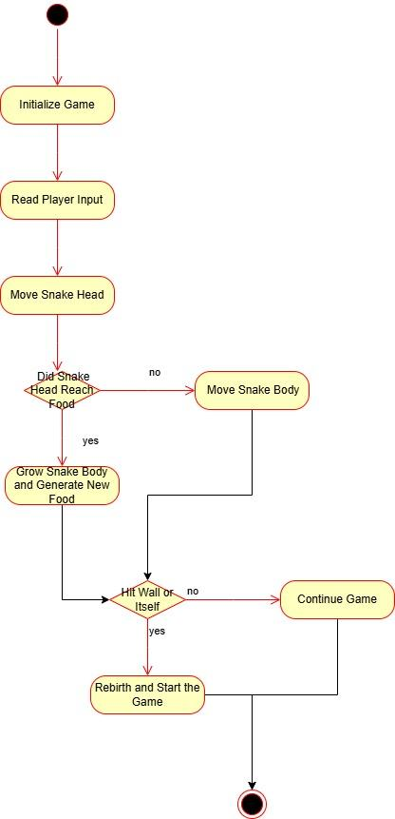

2.3 Schedule

Weak | Task
Weak 1 | Create Unity Universal 2D project
Weak 2 | Create snake head, body and food
Weak 3 | Writing codes
Weak 4 | Create start/ quit button, and title name
Weak 5 | Writing codes about interface
Weak 6 | Finish game and test game

3 Game Engine

A small game (programming language is C#) created using the Unity Universal 2D game engine.

3.1 Gameplay
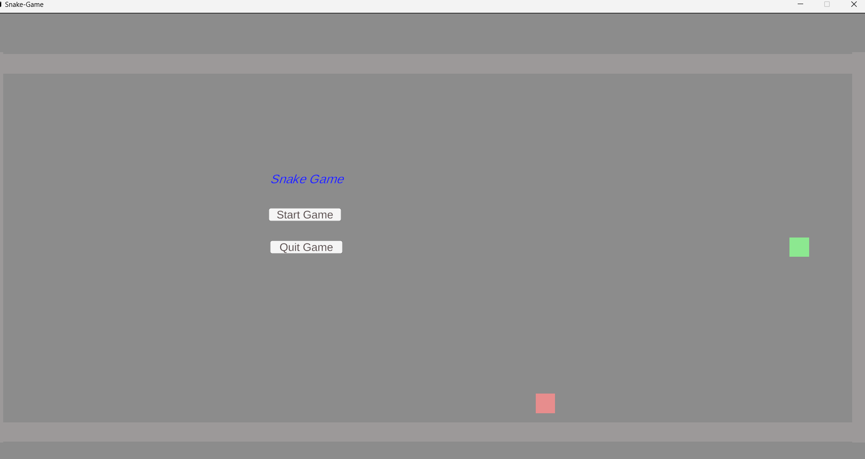
Click the start button with the mouse to start the game. First of all, the WSAD key is used to control the up and down, left and right directions. When you eat an apple, you will add one point, and if you block the wall or eat your own tail, you will start again.

4 Future planning
In the future, rich game pictures may be added, and the interface may be improved. Online multiplayer mode may be added on the basis of this game to make the game more eye-catching.

5 Conclusion
In conclusion, this project successfully demonstrates the design and implementation of a modern interpretation of the classic Snake arcade game. Rooted in the iconic gameplay mechanics popularized by the Nokia 6110 in 1997, the developed game preserves the core challenge of guiding a growing serpent to consume food while avoiding self-collision and boundary contact. the implementation of real-time directional controls and collision detection systems, the game provides immediate feedback to the player, ensuring that each session is both intuitive and increasingly difficult as the snake's length expands.

Ultimately, this project confirms that despite the evolution of video game technology over the past four decades, the fundamental appeal of Snake—the tension between growth and survival—remains a compelling and educational cornerstone of game design.

6 References
[1][1.1]https://en.wikipedia.org/wiki/Snake_(video_game_genre)

6.1 URL

Github: https://github.com/1258StevenKeong/Snake-Game.git

